Distributed System
HW #4

- Suppose the following sequence of events take place among a multicast group consisting of three processes P1, P2, and P3:
t1: P1 broadcasts m1
t2: P2 broadcast m2
t3: P3 broadcasts m3 in response to m1
t4: P2 broadcast m4
t5: P1 broadcasts m5 in response to m2
t6: P1 broadcasts m6 in response to m3
Unless specified, the messages are not causually related. (For example, m1 and m3 ARE causally related; m1 and m2 are not.)
All three processes behave correctly throughout the events.
For each of the following scenarios, circle in the corresponding table entry whether it is permitted or not (yes(Y) or no(N)) by that mode of multicast. The messages are listed in the order of their delivery.
- Each process is delivered m1, m2, m3, m4, m5, m6
- P1 and P3 are each delivered m1, m2, m3, m4, m5, m6.
P2 is delivered m1, m2, m4, m5, m3, m6.
- P1 is delivered m1, m2, m5, m3, m6, m4
P2 is delivered m2, m1, m4, m3, m5, m6
P3 is delivered m1, m4, m3, m2, m5, m6
- P1 is delivered m1, m2, m3, m4, m5, m6.
P2 is delivered m2, m1, m3, m6, m4, m5
P3 is delivered m1, m4, m3, m2, m5, m6.
- P1 is delivered m2, m1, m3, m5, m6, m4.
P2 is delivered m1, m2, m6, m5, m4, m3.
P3 us delivered m1, m2, m3, m4, m5, m6

(Y = permitted, N = not permitted)
Scenario | Causal  broadcast | FIFO  broadcast | Atomic  broadcast
1 | Y | Y | Y
2 | Y | Y | N
3 | Y | N | N
4 | Y | N | N
5 | Y | Y | N

- Consider a system where processes can be dynamically created or terminated. A process can generate a new process. For example, P₁ generates both P₂ and P₃. Modify the happened-before relation and the linear logical clock scheme for events in such a dynamic set of processes.

- For the distributed system shown in the figure below.

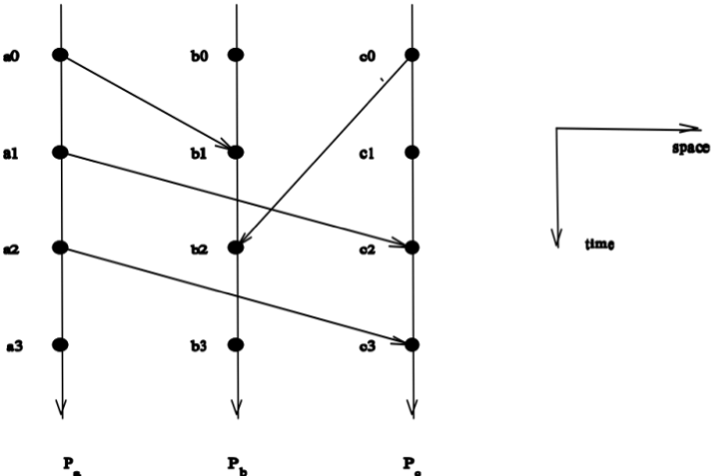

(1) Provide all the pairs of events that are related.
P1 sends a message to P2 and P2 receives the message
P3 sends a message to P2 and P2 receives the message
P1 sends a message to P3 and P3 receives the message
P1 sends a message to P3 and P3 receives the message

(2) Provide logical time for all the events using
(a) linear time, and
P1 sends a message to P2 t = 1
P3 sends a message to P2 t = 2
P1 Sends a message to P3 t = 3
P1 sends a message to p3 t=4

(b) vector time
P1 sends a message to P2 (1,0,0)
P3 receives the message from P1: (2,1,0)
P3 sends to P2: (2,0,1)
P1 sends to P3: (3,1,0)
P1 sends a message to P3: (4,2,0)

(Assume that each LC_{i} is initialized to zero and d = 1.)

- Provide an addressing scheme for the following extended mesh (EM) topology (only four nodes are shown in the figure, others omitted.). Then provide a general shortest routing algorithm for EMs (please refer to hypercube addressing scheme and mesh and its XY-routing/ZigZag-routing)

